

AI WeatherWise - Deliver intelligent weather forecasts and insights.

Team members:
- Sham D (Team leader)
- Rajesh P
- Rajiv Adhitya R V
- Samraj M



AI WeatherWise - Deliver intelligent weather forecasts and insights

Description
AI Weather-wise is a RESTful backend application developed using Node.js and Express.js. It uses MongoDB and Mongoose to store user and location information.
The system gets real-time weather information and uses Google Gemini AI to give simple weather summaries and useful recommendations.
The application has JWT authentication for security and uses bcrypt to protect user passwords. Users can also add, view, update, and delete their favourite locations.
The system also has a fallback option, so the application can still work when external API keys are not available. It also includes error handling and basic request validation.
Scenario-Based Case Study
Background
Alex likes travelling to different cities. He wants an easy way to check the weather of different places and get useful suggestions based on the current weather.

Problem
- Alex faces some problems:
- It is difficult to manage many favourite cities.
- He does not get personalized suggestions for activities or clothing.
- Raw weather data is not easy to understand.
- He needs a secure system to save his favorite locations and user information.
Solution
- AI WeatherWise provides one system to solve these problems.
- It allows users to:
- Manage their favorite cities.
- Get real-time weather information.
- Get simple weather summaries using AI.
- Get recommendations based on the current weather.
- Store user and location information securely.
The system uses Google Gemini AI for generating weather summaries and recommendations.
Usage
User Usage
Users can:
- Add favorite cities.
- View favorite cities.
- Update favorite locations.
- Delete favorite locations.
- Check real-time weather.
- Get AI weather summaries.
- Get AI recommendations.
Developer/Admin Usage
Developers or admins can:
- Check whether the API is working.
- Manage user registrations.
- Check the weather service.
- Check the AI service integration.
Weather Application User
Users can also access the public weather endpoint to get current weather information without creating an account.

Outcome
AI WeatherWise helps users understand weather information easily. It provides real-time weather data and uses Gemini AI to give simple weather summaries and useful recommendations. User and location data are securely stored using MongoDB and Mongoose.
1. Software Requirements
- OS: Windows 10/11, macOS, or Linux
- Node.js: v16 or above – runs the backend server
- npm: v8 or above – manages project packages
- Gemini AI SDK: Provides AI-based weather insights
- MongoDB: Stores user and favorite location data
- Mongoose: Manages MongoDB data and schemas
- Postman / Thunder Client: Tests API endpoints
- Visual Studio Code: Used for project development
2. Hardware Requirements
- Processor: Intel Core i5 / AMD Ryzen 5 or equivalent
- RAM: Minimum 8 GB
- Storage: At least 1 GB free space
- Internet: Required for weather and AI services
Topic 1: PROJECT ARCHITECTURE
AI WeatherWise uses a modular backend architecture. The project is divided into different modules to make development and maintenance easier.
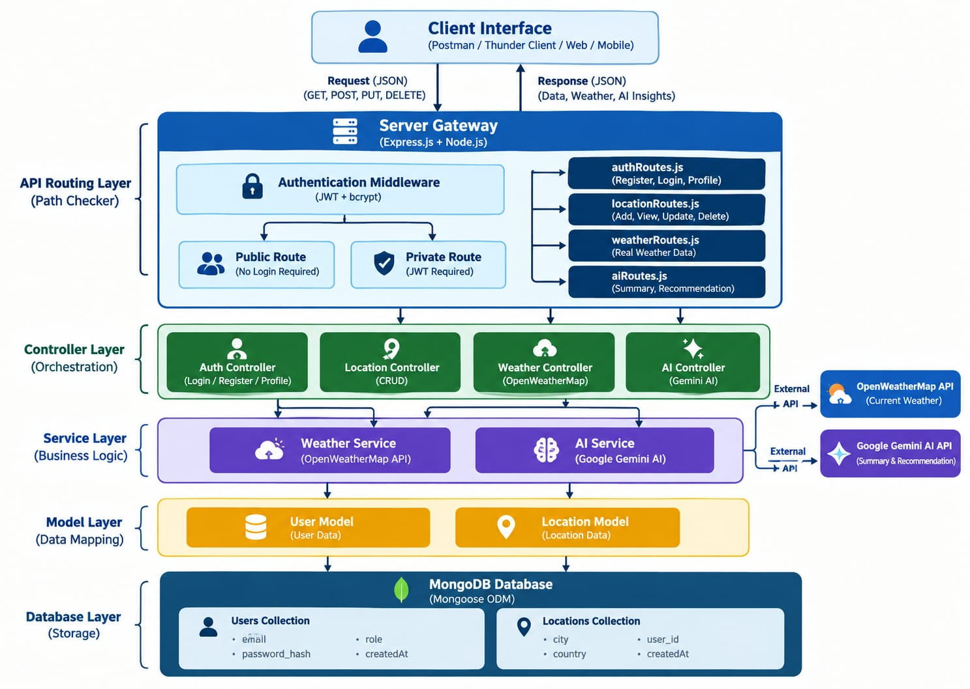
PROJECT ARCHITECTURE – COMPONENTS
The AI WeatherWise application follows the MVC pattern to separate application logic from database management. The Controller layer manages weather and AI operations, while the Model layer manages User and Location data.
Components Definition
Interface: Postman or Thunder Client is used to send API requests and receive JSON responses.
Express Server Gateway: Handles HTTP requests such as GET, POST, PUT, and DELETE. It also handles JSON data and CORS.
Authentication Middleware: Checks the JWT token and verifies whether the user is authorized to access protected APIs.
Route Layer: Contains separate routes for authentication, locations, weather, and AI operations.
Controller Layer: Handles the main application logic for user authentication, favorite locations, weather data, and AI requests.
Service Layer: Connects the application with OpenWeatherMap API for weather data and Google Gemini AI for summaries and recommendations.
Database Interface Layer: Mongoose is used to connect the application with MongoDB and manage database operations.
Model Layer: Contains User Model and Location Model to store and manage user and favorite location information.
AI Service Integration: Uses Google Gemini AI to generate simple weather summaries and personalized recommendations based on temperature and weather conditions.
Entity-Relationship (ER) Diagram Description
The system contains two main entities: User and Location.
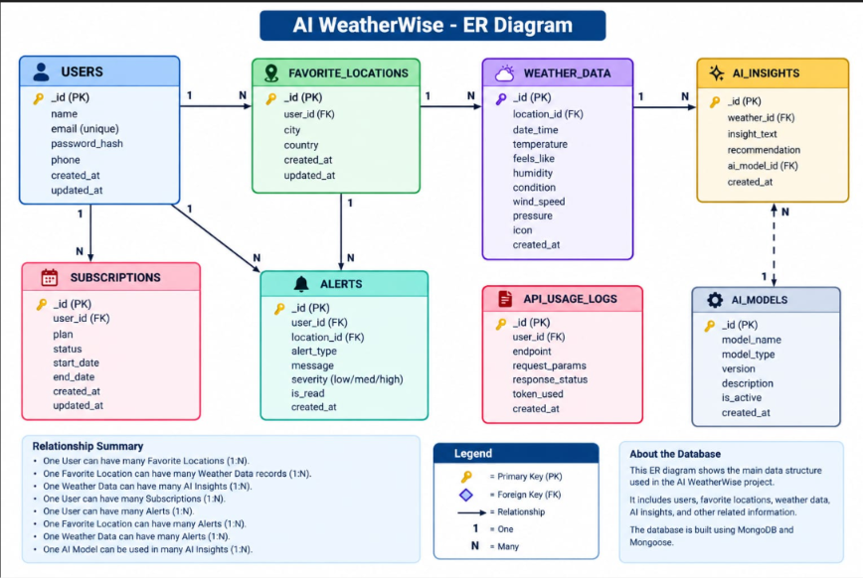

Database Entities
User Entity | Location Entity
- _id: Primary Key – ObjectId | - _id: Primary Key – ObjectId
- name: User name | - user: User ID that connects the location with the user
- email: User email, required and unique | - city: City name
- password: Hashed password | - country: Country name
- createdAt: Account creation date | - createdAt: Location creation date

Key Structural Mapping
User to Location – One-to-Many
One registered user can save multiple favorite locations.
User (1) → Location (Many)
Each location belongs to one user.
Key Features
- User Authentication: JWT is used to protect private APIs.
- Password Security: Bcrypt is used to hash user passwords.
- Favorite Locations: Users can add, view, update, and delete favorite locations.
- Real-Time Weather: OpenWeatherMap provides current weather information.
- AI Weather Summary: Gemini AI provides simple weather summaries.
- AI Recommendation: Gemini AI gives recommendations based on weather conditions.
- Data Storage: MongoDB stores user and favorite location information.
- API Validation: The application checks required data before processing requests.
Roles and Responsibilities
- Admin / Developer
- Monitor the API and server status.
- Manage user information when required.
- Check database and service operations.
- Verify weather and AI service integration.
- Registered User
- Register and login securely.
- Manage favorite locations.
- Get real-time weather information.
- Request AI weather summaries.
- Get activity recommendations.
- Manage their profile information.
User Flow
- Register or Login: The user creates an account or logs into the system.
- Save Location: The user adds a favorite city using the API.
- Get Weather: The system fetches the current weather information for the selected city.
- Get AI Insights: The user requests an AI weather summary or recommendation.
- Authentication: The system checks the JWT token for protected requests.
- Response: The system sends the requested information as a JSON response.
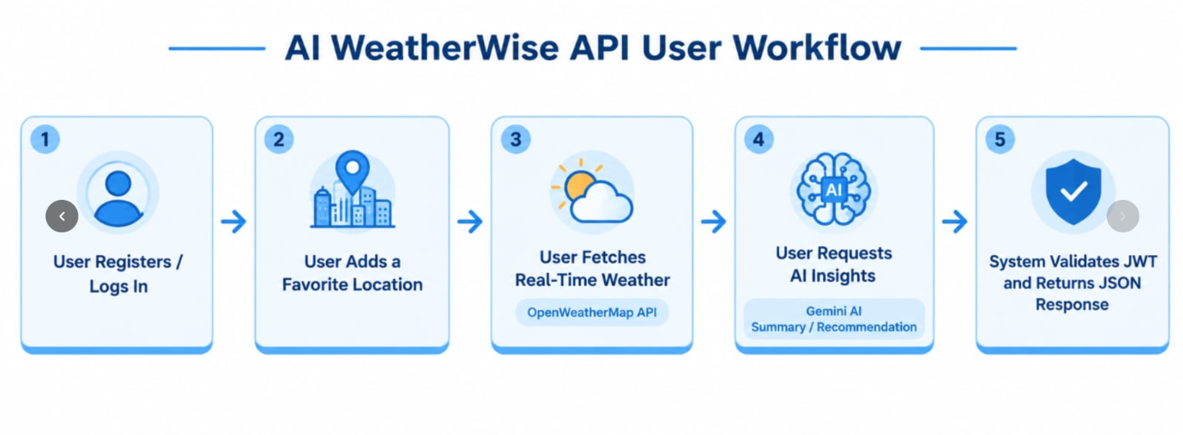

MVC Architecture Pattern
The AI WeatherWise application uses the MVC (Model-View-Controller) pattern to separate different parts of the application.
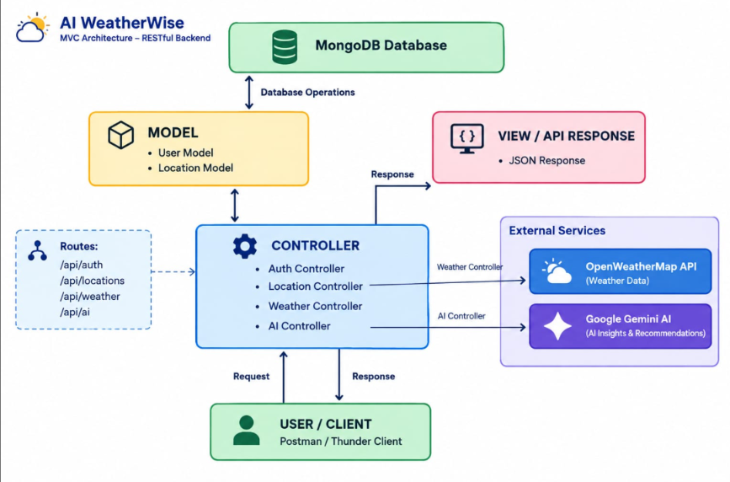
Model Layer – Data Structure
- The Model Layer defines the structure of the data stored in MongoDB. Mongoose schemas are used to define the fields and data types for the User and Location collections.
- It helps to validate and store data correctly in the database.
Main Models
- User Model – Stores user information.
- Location Model – Stores favorite location information.
Controller Layer – Application Logic
The Controller Layer handles the main application logic. It receives requests from the API routes, checks the required data, and performs the requested operation.
It handles:
- User registration and login
- User profile
- Favorite location management
- Weather requests
- AI summary requests
- AI recommendation requests
After processing the request, the Controller sends the result back as a JSON response.
View Layer – API Interface
AI WeatherWise is a headless backend application, so it does not have a normal web page or frontend.
Instead, Postman or Thunder Client acts as the interface for testing the API. Users or applications send requests to API routes and receive JSON responses.
Example API Routes
- /api/auth – Authentication
- /api/locations – Favorite locations
- /api/weather – Weather information
- /api/ai – AI summaries and recommendations
Topic 2: Project Setup and Configuration Creating the Project Folder
Create a new folder named AI WeatherWise.
- Open the project folder in Visual Studio Code.
- Open the terminal in VS Code.
- Initialize the project using Node.js.
Project Initialization
Run the following command:
npm init -y
Install the required packages:
npm install express mongoose bcryptjs jsonwebtoken cors dotenv @google/genai
Install Nodemon for development:
npm install --save-dev nodemon
Main Files
Create the following files:
- index.js – Starts the backend server.
- .env – Stores environment variables such as port and API keys.
- package.json – Contains project information, scripts, and dependencies.
- .gitignore – Prevents sensitive or unnecessary files from being uploaded.
Project Folder Structure
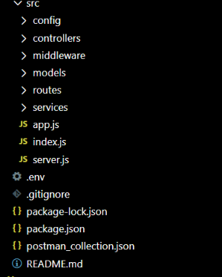
Environment Configuration
Create a .env file in the project root folder and add the required environment variables.
PORT=5001
MONGO_URI=your_mongodb_connection_string
JWT_SECRET=your_jwt_secret
OPENWEATHER_API_KEY=your_openweather_api_key
GEMINI_API_KEY=your_gemini_api_key

Environment Variables
- PORT: Port number used to run the backend server.
- MONGO_URI: MongoDB connection string.
- JWT_SECRET: Secret key used for JWT authentication.
- OPENWEATHER_API_KEY: API key used to get real-time weather data.
- GEMINI_API_KEY: API key used for Gemini AI services.
Note: Actual API keys should not be shared publicly or uploaded to GitHub.
Topic 3: Backend Development
- The AI WeatherWise backend is developed using Node.js, Express.js, and MongoDB. It follows a modular architecture to keep the project simple and easy to maintain.
- The application separates routes, controllers, middleware, models, and services into different modules.
The backend provides secure REST APIs for:
- User registration and login
- User profile management
- Favorite location management
- Real-time weather information
- AI weather summaries
- AI recommendations
Backend Structure
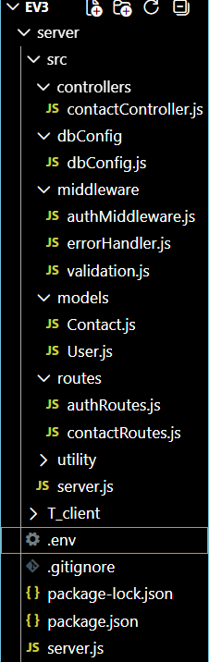
Core System Script Implementations
1. Application Entry Point (index.js)
The index.js file is the main entry point of the AI WeatherWise backend.
It performs the following tasks:
- Loads environment variables.
- Imports the Express application.
- Connects to MongoDB using Mongoose.
- Starts the backend server.
- Uses the port number from the .env file.
The server starts only after a successful database connection.
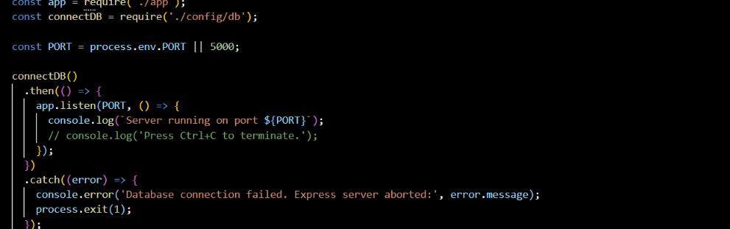
Epic 4: Database Configuration
1. Configure MongoDB
AI WeatherWise uses MongoDB to store user and favorite location information.
Install Mongoose using:
npm install mongoose
2. Database Connection
A separate database connection module is used to connect the Node.js application with MongoDB.
The connection is established before the server starts accepting API requests.
3. Mongoose Schema Definitions
User Schema
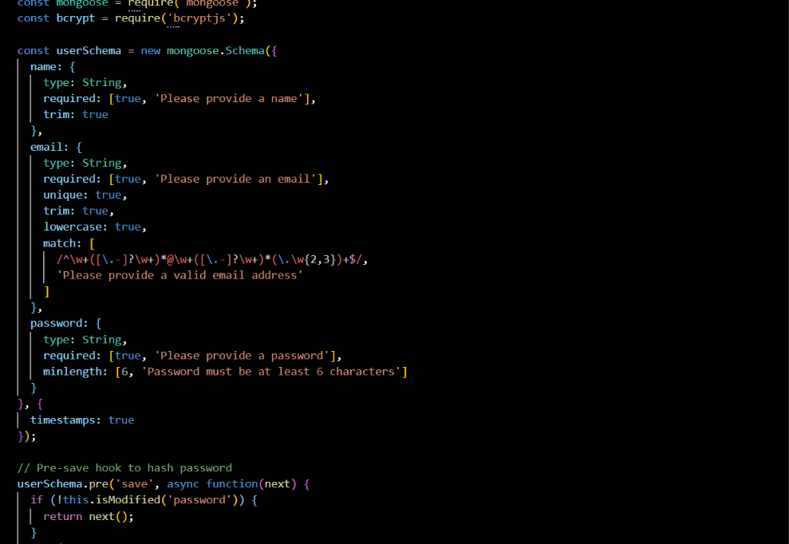
Location Schema
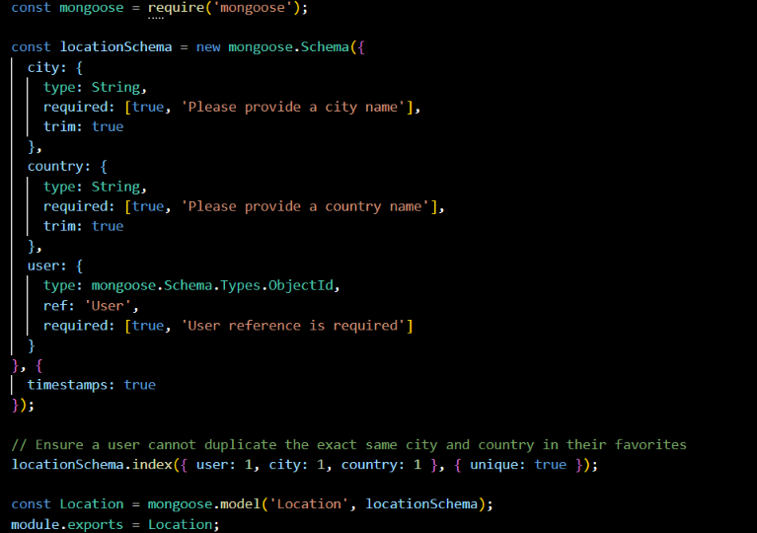
Db connection:
This module establishes a connection between the application and MongoDB using Mongoose. It ensures that the backend communicates with the database before processing any client requests.
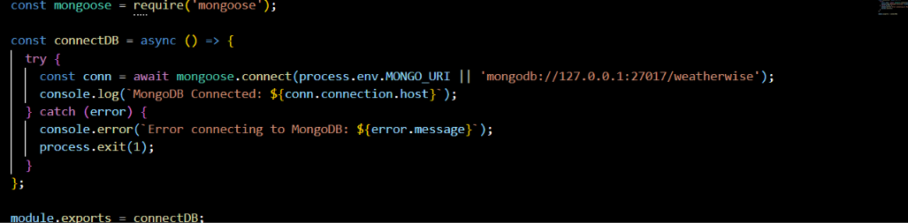
Epic 5: Project Execution
The AI WeatherWise backend can be run locally using Node.js. Before starting the project, make sure the .env file contains the required configuration and the MongoDB connection is available.
The backend provides REST APIs that can be tested using Postman or Thunder Client.
Running the Backend Server
Install the required packages:
npm install
Start the server:
npm start
After successful execution, the application connects to MongoDB and starts the server.
Example:
MongoDB Connected
Server running on port 5001
API Testing
The main APIs can be tested using Postman or Thunder Client.
1. Register API
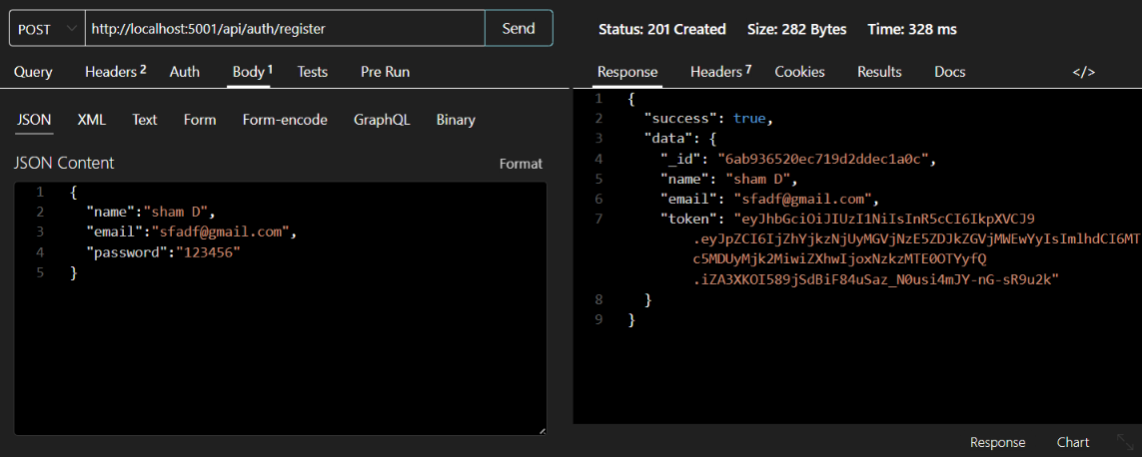2. Login API
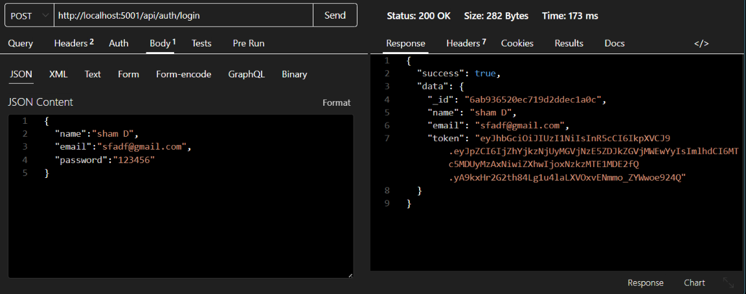

3. Profile API
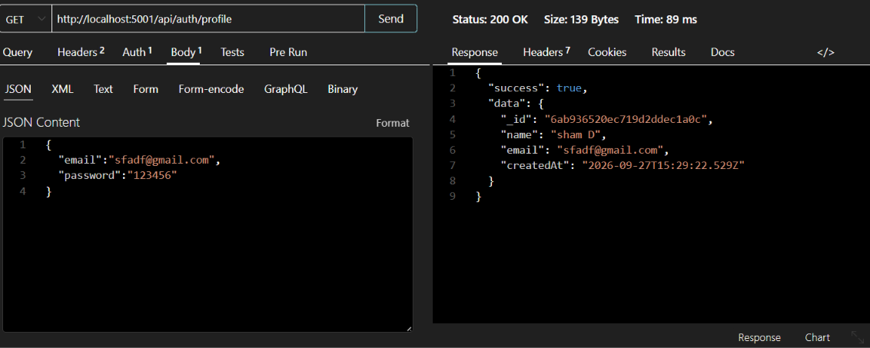
4.Location API
PUT LOCATIONS
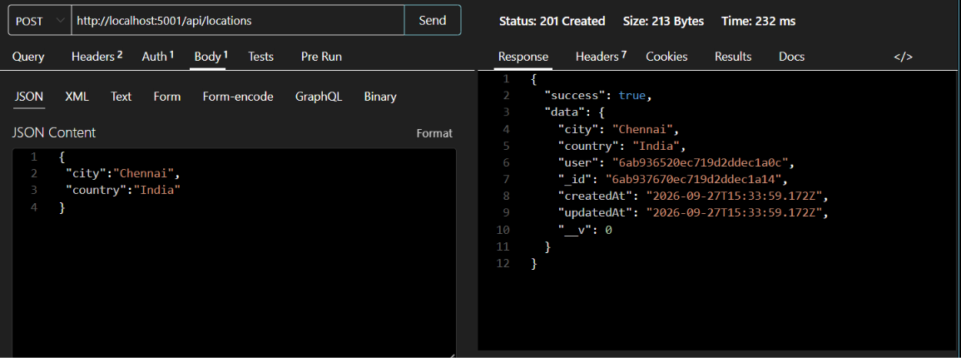
GET LOCATIONS
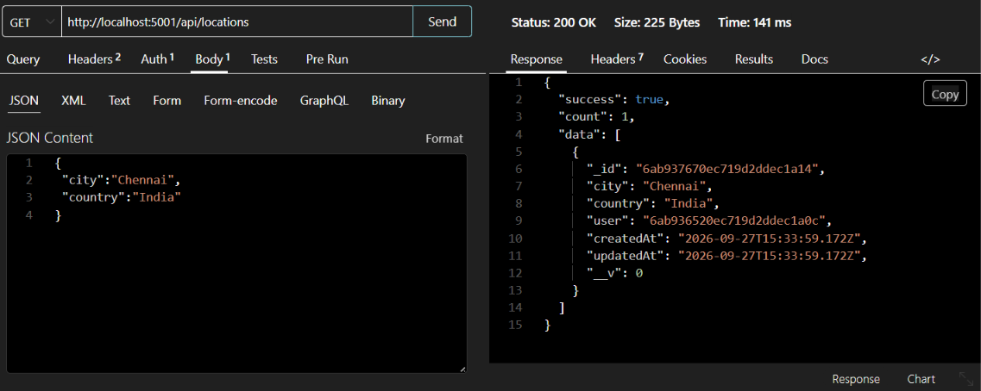
UPDATE LOCATION
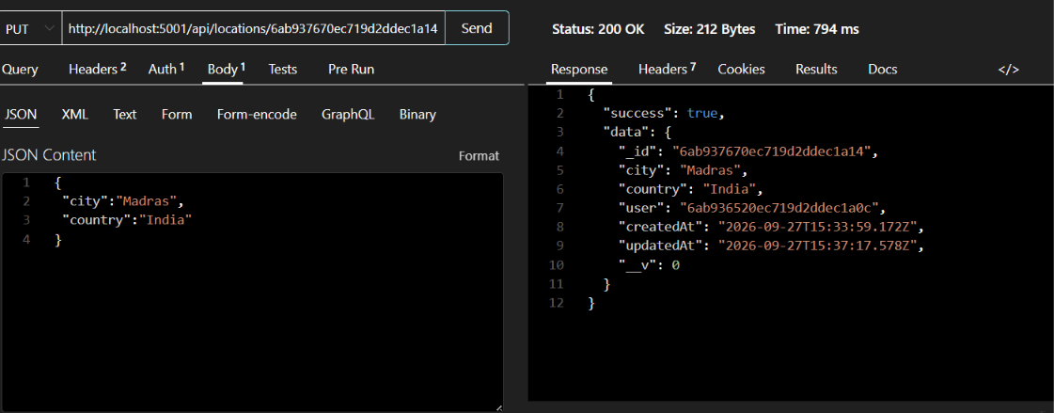
DELETE LOCATION
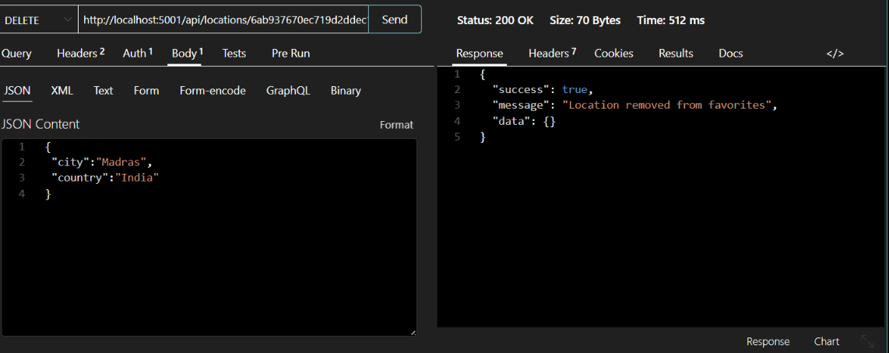
5.Weather API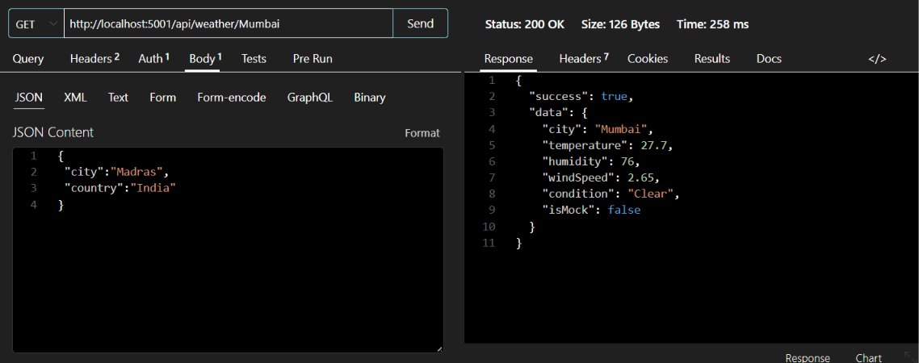

6.AI Summary API
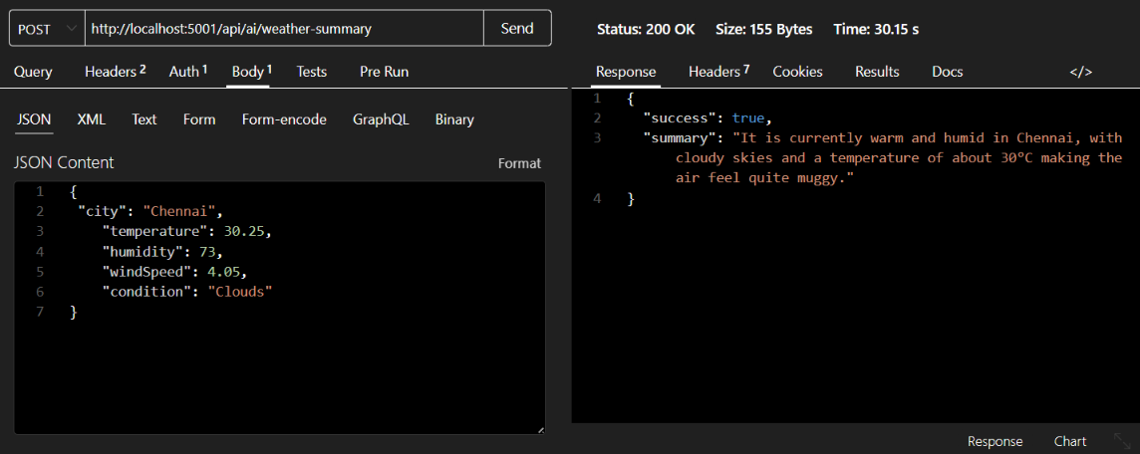

7. AI Recommendation API
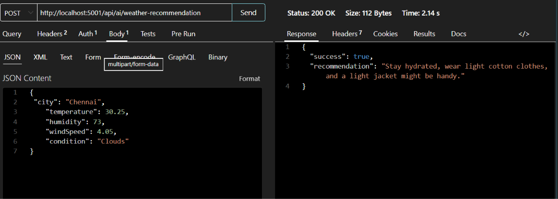Complete Testing Flow
Register → Login → Get JWT → Add Location → Get Weather → AI Summary → AI Recommendation
MONOGODB CONNECT
Get the monogodb cluster link, login with in your google account and create cluster the connect the database with your backend and monogobd compass app.
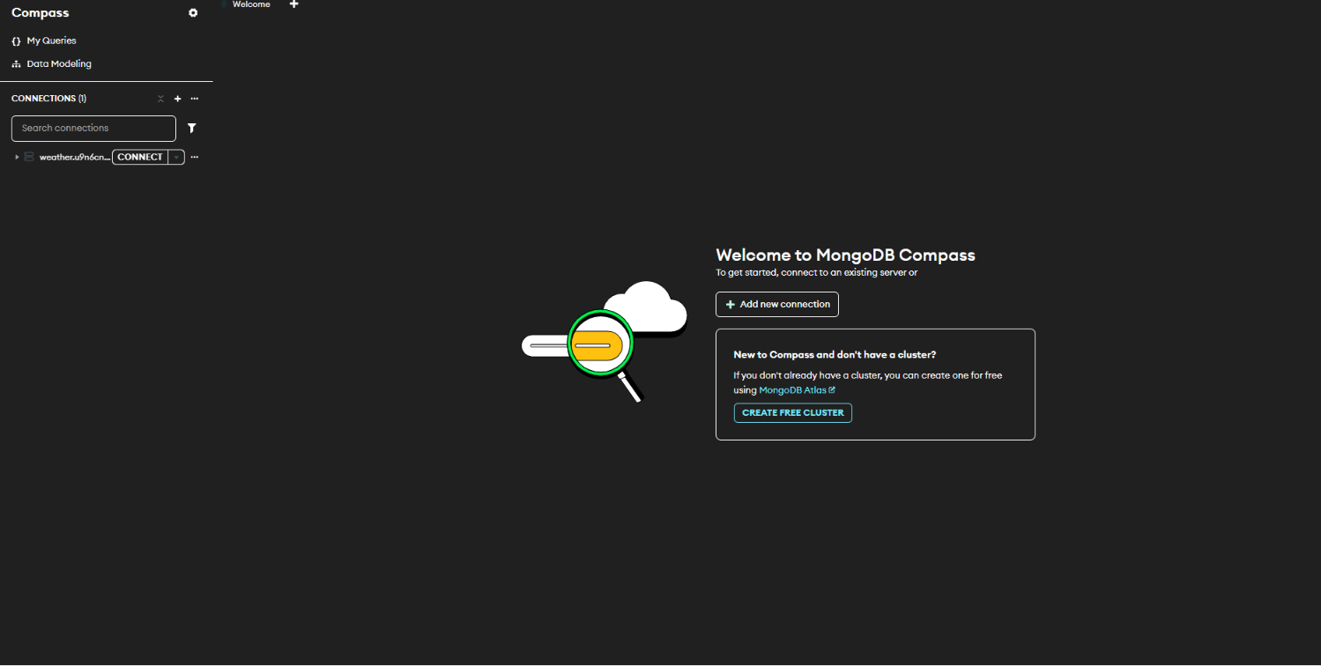
CONNECT TO DATABASE
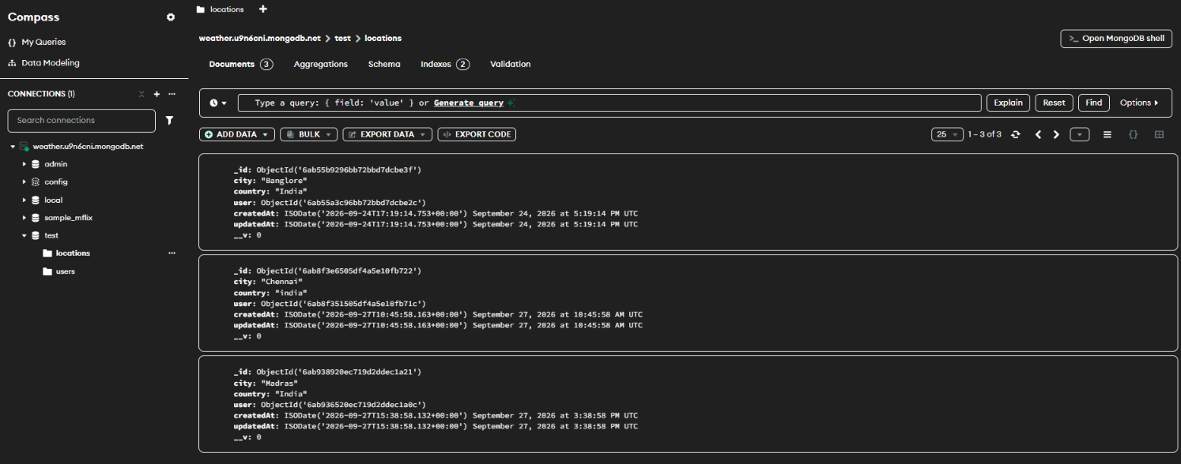
It shows that the users and locations.
CONNECT API KEYS
GEMINI API KEY
Copy and paste the API key to connect ai to our backend project GEMINI_API_KEY

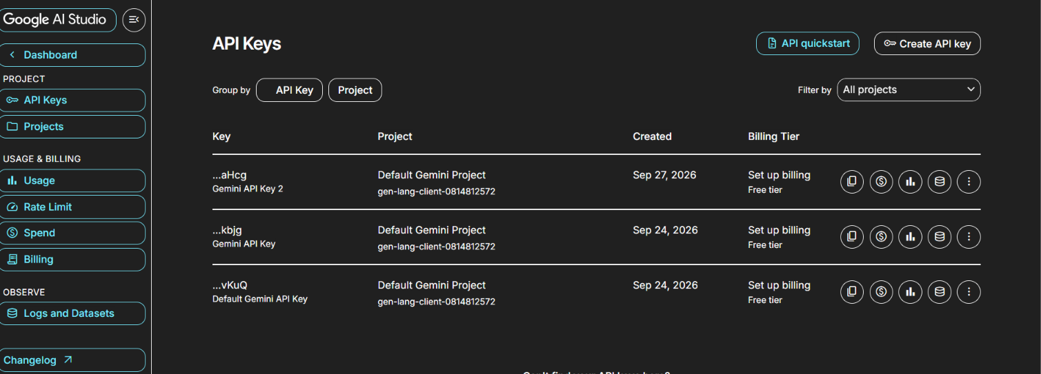

OPEN WEATHER API KEYS
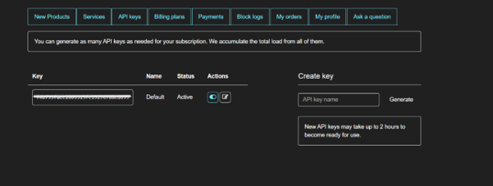

Demo Video Link: https://drive.google.com/file/d/1eI-X0lSkTNuWnqO-HimCCnLGeEmxUMvF/view?usp=sharing
Github link:https://github.com/mgc7sham24-dot/AI-WeatherWise-API

